* BREAKING



Red Sox 10, Braves 8, Final



*30g protein and nutrients to support immune health*

10% off coupon

Ensure Max Protein Nutritional Shake with 30g …



**Dorchester man charged in**

**Prudential Center Mall break-ins**

**By John Hilliard** Globe Correspondent, November 7, 2018, 2:35 p.m.

**2**

A Dorchester man wanted by Boston police for two burglaries at the Prudential Center Mall in late October was arrested early Wednesday, the department said in a statement.

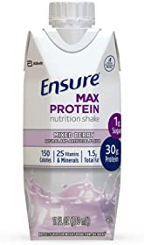

*30g protein and nutrients to support immune health*

10% off coupon

Ensure Max Protein Nutritional Shake with 30g of …

Cheval Holmes, 48, of Dorchester, was sought in connection with the theft of 30 watches from a Prudential Center Mall kiosk on Saturday, Oct. 27, and Wednesday, Oct. 31, police said in the statement, which was posted to the city’s website.

Officers assigned to District D-4 in the South End located Holmes at about 2:11 am.

“Officers placed the suspect in custody without incident while recovering a screwdriver from inside his coat pocket,” the statement said.

Advertisement

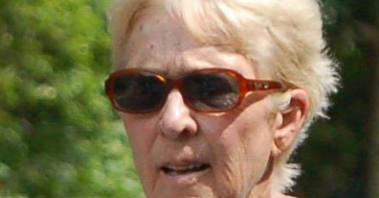

**Grandma Attacked Outside Store In Roslindale**

Sponsored by SafeAlarm

Holmes was expected to be arraigned Wednesday at Boston Municipal Court on two counts of breaking and entering, as well as larceny and possession of burglarious tools, according to the court clerk’s office.

[John Hilliard can be reached at john.hilliard@globe.com.](mailto:JohnHilliardcanbereachedatjohn.hilliard@globe.com)

**Show comments**

**BOSTON GLOBE VIDEO**

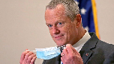

2:23

Baker announces ‘VaxM SHARE

Governor Charlie Baker announced residents who are fully vaccinated against COVID-19 will have the chance to win $1 million in a special Lottery sweepstakes. (Photo by Matt Stone/Boston Herald via AP)

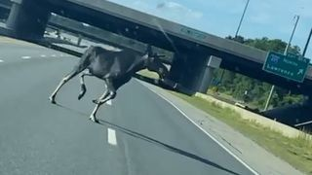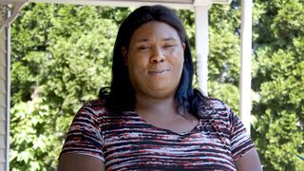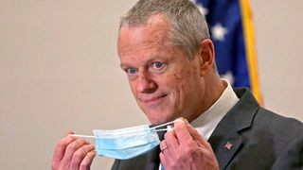

**Baker**

**Moose What**

**announce spotted Black ‘VaxMillio on liberation lottery Route 3 means program in to me:**

**Chelmsfo Athena**

**Vaughn**

**NOW PLAYING**

**MOST POPULAR ON BOSTONGLOBE.COM**

1. Baker announces ‘VaxMillions’ lottery program, offering $1 million cash prizes to boost vaccination rates
2. Message in a bottle, tossed into the sea in Rhode Island, found in Azores
3. Life sciences is poised to be Boston’s dominant industry. Has the area become the Silicon Valley of biotech?
4. The downside of ditching masks: the return of colds, flu
5. The case for prosecuting Donald Trump
6. How white supremacy weaponizes ignorance
7. A treasure map for an American tyrant
8. ‘Boo Boo’ the South Shore Bear captured on video roaming in Duxbury
9. Paul Pierce to launch ‘Truth’ marijuana brand in Massachusetts
10. 5 things to know about the VaxMillions lottery sweepstakes in Mass.



**VIEWS FROM OUR COLUMNISTS**

**YVONNE ABRAHAM**

Energy efficiency is a low- hanging fruit to combat climate change. So why can’t everyone get access to it?

**KEVIN CULLEN**

Bill Bratton on American policing and the challenge facing the Boston Police Department

**THOMAS FARRAGHER**

A salute across the ages to an old squad leader

**SHIRLEY LEUNG**

A working mother’s manifesto: Pandemic provides a once-in-a- generation chance to course correct how we work

**JENEÉ OSTERHELDT**

Juneteenth and the meaning of Black liberation in Boston

**ADRIAN WALKER**

‘The best Boston movie no one’s ever seen’: ‘Blue Hill Avenue’ at 20

**MORE ON GLOBE.COM**

# SPONSORED BY: PHILIP MORRIS INTERNATIONAL

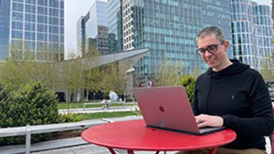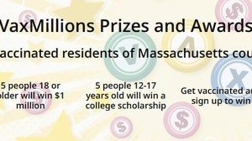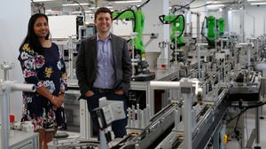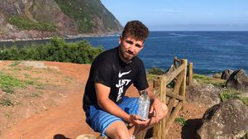

## Until recently, medical research mostly happened in person. The pandemic changed that

Research was “stuck in an old mindset,” says Martin Naley, a Boston-based entrepreneur and clinical informatics specialist.

## Baker announces ‘VaxMillions’ lottery program, offering $1 million cash prizes to boost vaccination rates

State officials on Tuesday said

residents who’re fully vaccinated against COVID-19 will have the chance to win $1 million in a special Lottery sweepstakes.

# INNOVATION ECONOMY

## Life sciences is poised to be Boston’s dominant industry. Has the area become the Silicon Valley of biotech?

Since December, you can find six major

indications that Boston is the undisputed center of the life sciences industry, a place where ideas and products that change ― and save ― people’s lives around the world originate.

# RI NEWS

## Message in a bottle, tossed into the sea in Rhode Island, found in Azores

The note was written in 2018 by a 13-

year-old who was visiting family in Rhode Island.

**The downside of ditching masks: the return of colds, flu** Since the state’s mask mandate was

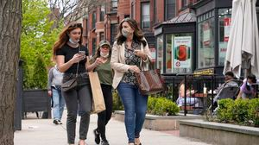

lifted, face coverings have started to

come off — and stay off. But according to infectious diseases doctors, the return of facial freedom might come with some downsides, like a resurgence in cases of the common cold and the flu.

## The case for prosecuting Donald Trump

Saving American democracy for the

long run requires a clear condemnation of the Trump presidency. That means making clear that no one is above the law.

# OPINION

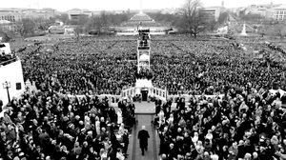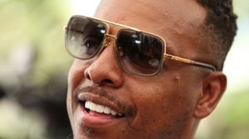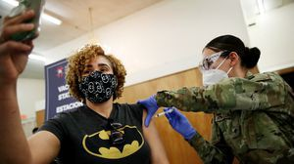

## How white supremacy weaponizes ignorance

Racists have always understood that if

they can censor what people learn, they can control what people believe.

## A treasure map for an American tyrant

Donald Trump exposed weaknesses

that a would-be dictator could exploit to end our democracy. It’s now up to lawmakers, voters, and public officials to prevent that from happening.

## Paul Pierce to launch ‘Truth’ marijuana brand in Massachusetts

The legendary ex-Celtic says cannabis

helped save his career after a traumatic stabbing in 2000.

## 5 things to know about the VaxMillions lottery sweepstakes in Mass.

Here are five things you should know

about the VaxMillions program, which will make some lucky winners living proof that trusting the science really does pay.

**s ns’**

**rd**



**METRO SPORTS BUSINESS & TECH OPINION**

WELCOME, JOHN

**TODAY'S PAPER**

**Check out this week's virtual events**

RSVP now

**LAWMAKERS STRIKE DEAL TO RESTORE PANDEMIC-ERA POLICIES, INCLUDING EVICTION PROTECTIONS, TO-GO COCKTAILS**

**MOST READ IN THIS SECTION**

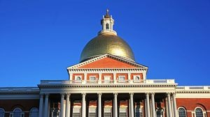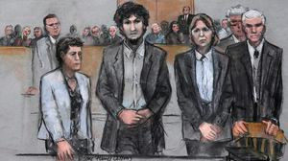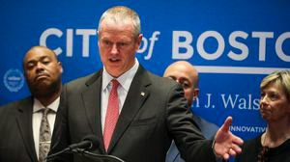

**5 things to know about the VaxMillions lottery sweepstakes in Mass.**

**Baker announces ‘VaxMillions’ lottery program, offering $1 million cash prizes to boost vaccination rates**

**RI NEWS**

**Message in a bottle, tossed into the sea in Rhode Island, found in Azores**

**Lawmakers reach compromise on restoring pandemic era-policies including to-go cocktails, outdoor dining**

**Death penalty should be reinstated for Tsarnaev in Boston Marathon bombings case, Biden administration tells Supreme Court**

**The downside of ditching masks: the return of colds, flu**

**State licensing loopholes keep thousands of bad drivers on the road**

**America's blind spot: Thousands of drivers shouldn't be licensed**

**Study says COVID- 19 was likely present in Mass. as early as December 2019**

**FOLLOW US**

**SUBSCRIBE NOW MY ACCOUNT CONTACT MORE**



Digital Access Home Delivery

Gift Subscriptions

Log In

Manage My Account Customer Service

Help & FAQs Globe Newsroom

Advertise

Newsletters / View The EPaper /

Order Back Issues / News In Education / Search The Archives / Privacy Policy / Terms Of Service / Terms Of Purchase / Work At Boston Globe Media /

Do Not Sell My Personal Information

©2021 Boston Globe Media Partners, LLC